**B2C Commerce - PRIOS INTEGRATION**

*Version 23.1.0*



Table of Contents

1. Summary 3

2. Component Overview 4

Functional Overview 4

Use Cases 6

Limitations, Constraints 9

Compatibility 9

*Cartridge developed in SiteGenesis v105.2.1, SFRA v6.1.0* 9

Privacy, Payment 9

3. Implementation Guide 10

Setup of Business Manager 10

Configuration 12

Custom Code 13

External Interfaces 13

Firewall Requirements 13

4. Testing 14

5. Operations, Maintenance 15

Data Storage 15

Availability 15

Failover/Recovery Process 15

Support 15

6. User Guide 16

Roles, Responsibilities 16

Business Manager 16

Storefront Functionality 19

7. Known Issues 19

8. Release History 19

# Summary

*The submitted Link Cartridge enables B2C Commerce users to seamlessly connect with PRIOS, an Instore digital mobile application. PRIOS will have basic and additional functionalities of a mobile commerce application for IOS. Subsequently, the Link Cartridge and PRIOS will be extended to support Instore digital features also.*

*Through B2C Commerce and PRIOS integration, customers can manage consumer interactions across all digital touch points globally, enabling a seamless and consistent brand experience on any channel. Our platform is built to support digital commerce best practices and can be customized to individual needs, with full access to a sophisticated Omni-channel marketing and merchandising engine and open development environment*.

# **Component Overview**

## Functional Overview

*PRIOS is a ready to plug-in B2C Commerce M-Commerce solution built on IOS. The solution gives the client the ability to extend their e-shop on mobile and customize it to their need. Our framework gives clients the option to customize the solution to suit their business as well as help them add M-Commerce capability in a short span of time.*

*PRIOS brings enormous value to B2C Commerce customers where it not only enables M-Commerce but also extends the app to enable in-store digital experience. Apart from the M-Commerce functionality like Search, Cart Management and Payments, the app also enables the stores to integrate their Offline store stocks, beacon base instore Marketing and Offline buying, visit a physical store, scan a product bar-code, add to cart, and then do a check out.*

*The current solution aims to connect the storefront with PRIOS mobile app with the help of out of box OCAPI API’s available in B2C Commerce. This cartridge provides the features unavailable out of the box in B2C Commerce.*

*Currently, the customizations include the following:*

* *Adding product image in the response when adding product to cart*
* *Adding product image in response while fetching the cart*
* *Adding custom attribute i.e., Brand of the product on hit of the search products API*
* *Allowing customer to reset password*
* *Job to purge PriosNewsLetterSubscription custom object instances*

*Screenshots of the PRIOS Mobile App:*

|  |  |
| --- | --- |
| *Home Page 1* | *Home Page 2* |
| *Menu* | *Product List* |
| *Product Details Page 1* | *Product Details Page 2* |
| *Cart Page* | *Place Order Page* |

## Use Cases

***Use Case – 1 (Add Item to Cart API):***

|  |  |
| --- | --- |
| *Add Item to Cart API* | *On adding a product to the Basket, product image should be available in response.* |
| *Goal in Context* | *While adding individual products into the Cart the product’s image should be added in the response.* |
| *Pre-conditions* | *Users should be able to add products to the Cart, and those products should have “small” size image configured.* |
| *Success End Condition* | *After the product is added to Cart successfully, the product image URL should be available in the response.* |
| *Failed End Condition* | *Either the product is not added in the Cart (or) in spite of product being added image URL in not updated.* |
| *Primary Actor* | *Customer* |
| *Trigger* | *On adding a product to Cart.* |
| *Description* | *When a product is being added to cart its image URL should also be present in the response.* |

***Use Case – 2 (Get basket API):***

|  |  |
| --- | --- |
| *Get basket API* | *On fetching the Basket, product image should also be available in response.* |
| *Goal in Context* | *While fetching the basket, the product’s image should be available in the response.* |
| *Pre-conditions* | *There should be added products in the basket and those products should have “small” size image configured.* |
| *Success End Condition* | *When the basket is fetched, the product image URL should be available in the response.* |
| *Failed End Condition* | *Either the basket is not fetched (or) the basket is fetched but the added image URL in not present in response.* |
| *Primary Actor* | *Customer* |
| *Trigger* | *On clicking on show Cart.* |
| *Description* | *When the customer selects show cart, along with the basket object, the image URL should also be present in the response.* |

***Use Case – 3 (Search Products API):***

|  |  |
| --- | --- |
| *Search Products API* | *Brand name should also come in the response of Search Product API.* |
| *Goal in Context* | *On search of a product in the search box (or) on clicking in the subcategory along with the products its brand should also come in the response.* |
| *Pre-conditions* | *Products should be configured in the catalog. Keyword searched in the search box should match with any products (or) the subcategory in which it is selected should have products assigned to it.* |
| *Success End Condition* | *The product tile page should be displayed, and each product should have a brand associated with it.* |
| *Failed End Condition* | *The product tile page is not displayed (or) the products do not have the brand associated with it.* |
| *Primary Actor* | *Customer* |
| *Trigger* | *On searching with a keyword on the search box or clicking the subcategory.* |
| *Description* | *On searching for a product in the search box (or) on clicking in the subcategory along with the products its brand should also come in the response.* |

***Use Case – 4 (Starts a password reset process API):***

|  |  |
| --- | --- |
| *Starts a password reset process API* | *On selecting reset password, an email will be triggered to the registered mail id of customer which will contain the reset link of setting up the new password.* |
| *Goal in Context* | *Must send an email to respective mail ID that is passed with identification parameter in the body of the API that contains the link which contains the form to change the password.* |
| *Pre-conditions* | *Having OAuth token with the registered username, password, and client id.* |
| *Success End Condition* | *An email will be triggered to the registered mail id of customer which will contain the reset link of setting up the new password.* |
| *Failed End Condition* | *An email will not be triggered to the registered mail id of customer.* |
| *Primary Actor* | *Customer* |
| *Trigger* | *On selecting reset password button.* |
| *Description* | *When the customer selects reset password, an email will be triggered to the registered mail id of customer consisting of the reset link of setting up the new password.* |

***Use Case – 5 (ExportPriosNewsLetterSubscribers):***

|  |  |
| --- | --- |
| *ExportPriosNewsLetterSubscribers* | *On executing job "ExportPriosNewsLetterSubscribers" by passing file name, folder name and CustomObject Type name as parameters for job step. Job is executed with status "OK" and an xml file is created in the given folder in IMPEX directory with the instances of given CustomObjectType.* |
| *Goal in Context* | *To purge the custom object data whenever ExportPriosNewsLetterSubscribers job is executed.* |
| *Pre-conditions* | *Custom Object Type already exists and has at least one instance in the database.* |
| *Success End Condition* | *Job should be executed with status "OK" and an xml file should be created in the given folder in IMPEX directory with the instances of given CustomObjectType.* |
| *Failed End Condition* | *Job should return "ERROR" status and an error log with the description should be written in the custom log file.* |
| *Primary Actor* | *Administrator* |
| *Trigger* | *On triggering ExportPriosNewsLetterSubscribers job.* |
| *Description* | *On executing job "ExportPriosNewsLetterSubscribers" by passing file name, folder name and CustomObject Type name as parameters for job step. Job is executed with status "OK" and an xml file is created in the given folder in IMPEX directory with the instances of given CustomObjectType.* |

***Use Case for the Out of the Box APIs:***

*Details regarding the out of the box APIs used in this integration are available here:*



## Limitations, Constraints

*PRIOS will have the basic and (coupon, promotions, wish list & order search) additional functionalities of a Mobile commerce application.*

*It is available only for iOS as of now.*

*Subsequently the Link Cartridge and PRIOS will be extended to support additional Instore digital features.*

## Compatibility

*Available since Commerce Cloud 17.8*

#### *Cartridge developed in SiteGenesis* [*v105.2.1*](https://github.com/SalesforceCommerceCloud/sitegenesis/releases/tag/v104.1.3)*, SFRA* [*v6.3.*](https://github.com/SalesforceCommerceCloud/storefront-reference-architecture/releases/tag/v4.4.1)*0*

*OCAPI Version used: v23.1*

*Tested against compatibility mode: 22.7*

*Supported Locales: en_US*

## Privacy, Payment

*NA*

# Implementation Guide

## Setup of Business Manager

*This integration provides a cartridge int_aspiresystems. This cartridge must be deployed on B2C Commerce instance. On deploying with proper OCAPI settings configured, the instance can be connected with the PRIOS Mobile app.*

*Add the int_aspiresystems cartridge in your workspace and connect to B2C Commerce server*

1. *In Eclipse IDE, select File > Import > Import Existing Projects into workspace, and browse to the int_aspiresystems cartridge and complete importing the cartridge into workspace.*
2. *This document assumes that the developer already has a working connection to their B2C Commerce instance and can add the project to this connection*

*Add the cartridge to your site cartridge path in Business Manager*

1. *Log in to Business Manager*
2. *Browse to Administration > Sites > Manage Sites and select the site you want to edit*
3. *Click the Settings tab and add int_aspiresystems at the beginning of the cartridge path separated by colon*
4. *Click Apply*
5. *Confirm that int_aspiresystems is listed in the “Effective Cartridge Path”*

*Add the cartridge to your BM site cartridge path in Business Manager*

1. *Log in to Business Manager*
2. *Browse to Administration > Sites > Manage Sites and select Business Manager Site*
3. *Click the Settings tab and add int_aspiresystems at the beginning of the cartridge path separated by colon*
4. *Click Apply*
5. *Confirm that int_aspiresystems is listed in the “Effective Cartridge Path”*

*Creating Log Category*

1. *Log in to Business Manager*
2. *Browse to Administration > Operations > Custom Log Settings*
3. *Under Custom Log Filters, enter* ***prios*** *as a Log Category, select WARN from Log Level dropdown and click Add*
4. *Click Save*

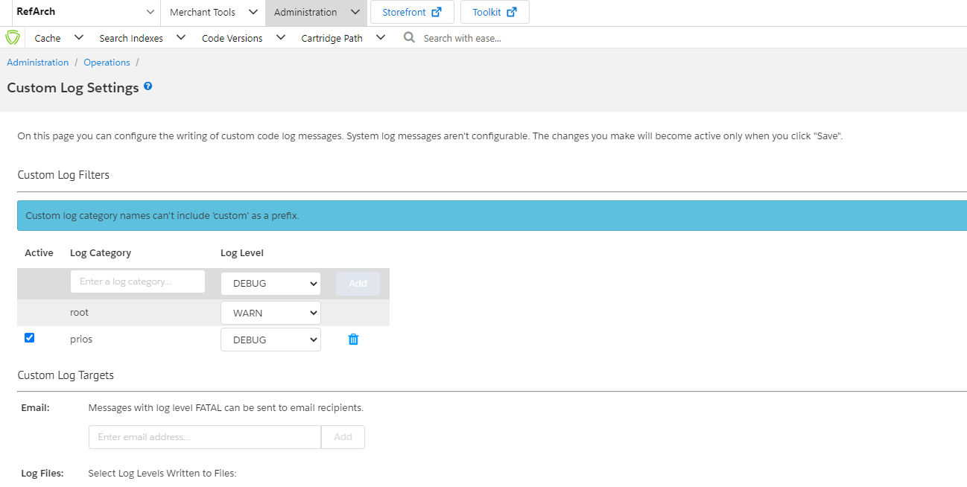

*IMPORT OF METADATA*

*Importing Custom Object: PriosNewsLetterSubscription & Importing Job Definition: ExportPriosNewsLetterSubscribers*

1. *Log in to Business Manager*
2. *Browse to Administration > Site Development > Site Import & Export*
3. *Under the Import section, select Local, click on Choose File and browse to PriosMetaData.zip file under metadata folder available in the repository and click on Upload*
4. *Check if the uploaded file is listed under the Import section*
5. *Select the uploaded file and click on Import*
6. *Select OK on the prompt “Are you sure you want to import the selected archive??”*
7. *Check the status of the Import under Status section*
8. *Confirm that the file is imported without any errors*
9. *Browse to Administration > Site Development > Custom Object Types and verify if the imported custom object type is listed in Custom Object Type List*
10. *Browse to Administration > Operations > Jobs and verify if the imported job is listed in the Jobs List*

## Configuration

Add the Open Commerce API settings in Business Manager on Global & Site level

1. *Log in to Business Manager*
2. *Browse to Administration > Site Development > Open Commerce API Settings*
3. *Select Shop from the type dropdown, and merge the shop API details below with existing OCAPI details*

*For SHOP API:*

*File:* 

*Note: Update allowed_origins value in the above file with allowed origin ID.*

1. *Select Shop from the type dropdown, and merge the below data API details with existing OCAPI details*

*For Data API:*

*File:* 

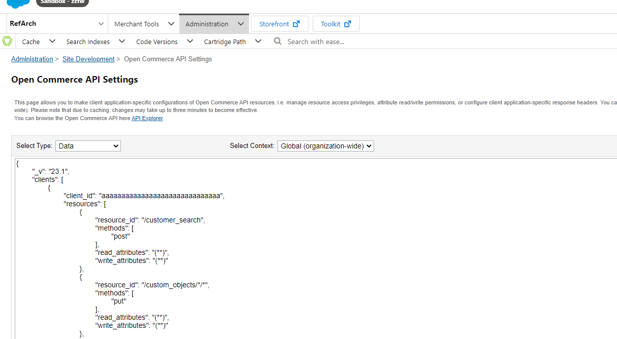

*Note: Replace the “client_id” with the actual value and replace the “allowed_origins” with your sandbox(s) URL.*

1. *Save the data.*

## Custom Code

*NA*

## External Interfaces

*NA*

## Firewall Requirements

*NA*

# Testing

* *For testing purposes, you can use a default Client ID as “aaaaaaaaaaaaaaaaaaaaaaaaaaaaaa”.*
* *For checking response of the Open Commerce API’s outside of the Mobile App, we can use postman tool.*
* *We can download the chrome extension for Postman.*
* *Further, create a new Tab and Add the URL along with its HTTP Method.*
* *Further add the required Headers i.e. (Authorization, Origin and Content-Type).*
* *If that URL requires a body, add that in the body by selecting raw (If it requires JSON input).*
* *We can import/export Postman Collections having all the API details in JSON format.*

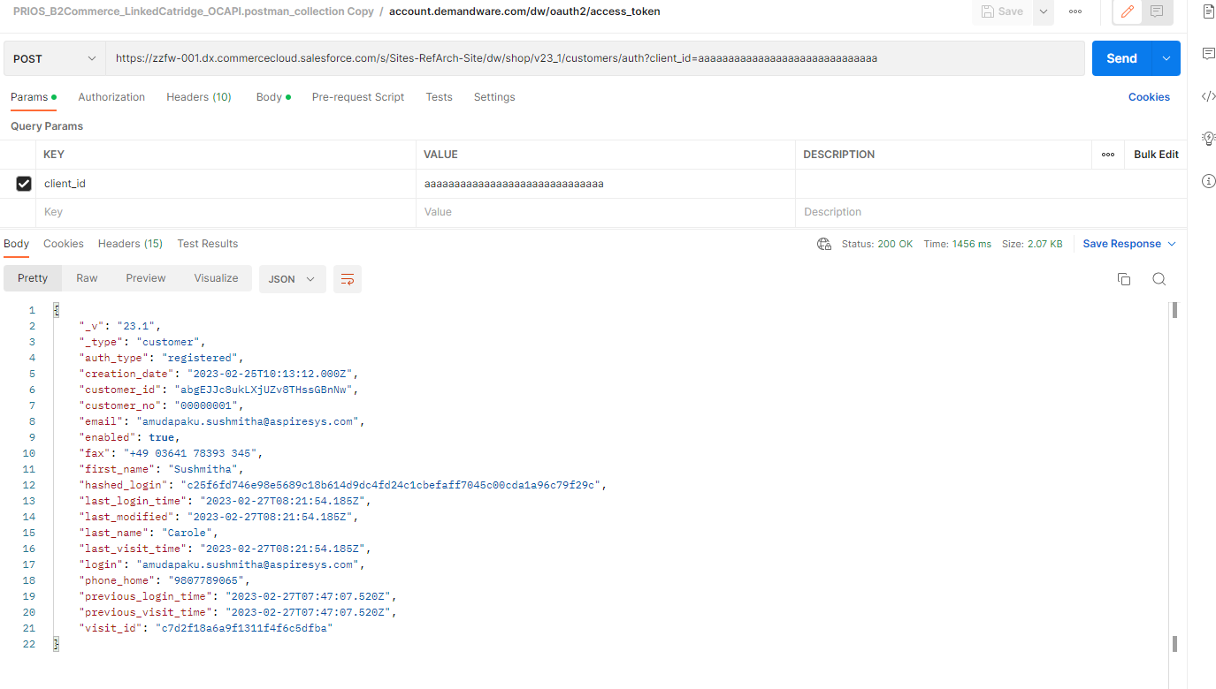

# Operations, Maintenance

## Data Storage

*Created global custom object for custom object type PriosNewsLetterSubscription to store email id for the customer and it would be used for email subscription.*

## Availability

*Since this Integration is based on Open Commerce API and no External Service is being used so there will be continuous uptime.*

## Failover/Recovery Process

1. *Check if the B2C Commerce instance is up and running.*
2. *Check all the BM configurations, cartridge upload onto server.*

## Support

*For Support Purpose, please contact sfcc@aspiresys.com.*

# User Guide

## Roles, Responsibilities

*Apart from the Cartridge Integration, no other recurring task is required.*

## Business Manager

*ExportPriosNewsLetterSubscribers Job Configuration Screenshots:*

*For Job General Configurations:*

*For Job Schedule and History Configurations:*

*For Job Resources Configurations:*

1. *Under the Resources tab, click Select*
2. *Under Resource Type drop-down, select Custom Resource*
3. *In the Value field, enter PriosNewsLetterSubscription and click Select*
4. *This will lock the PriosNewsLetterSubscription Custom Object Type Definition resource while the job is running*

*For Job Steps Configurations:*

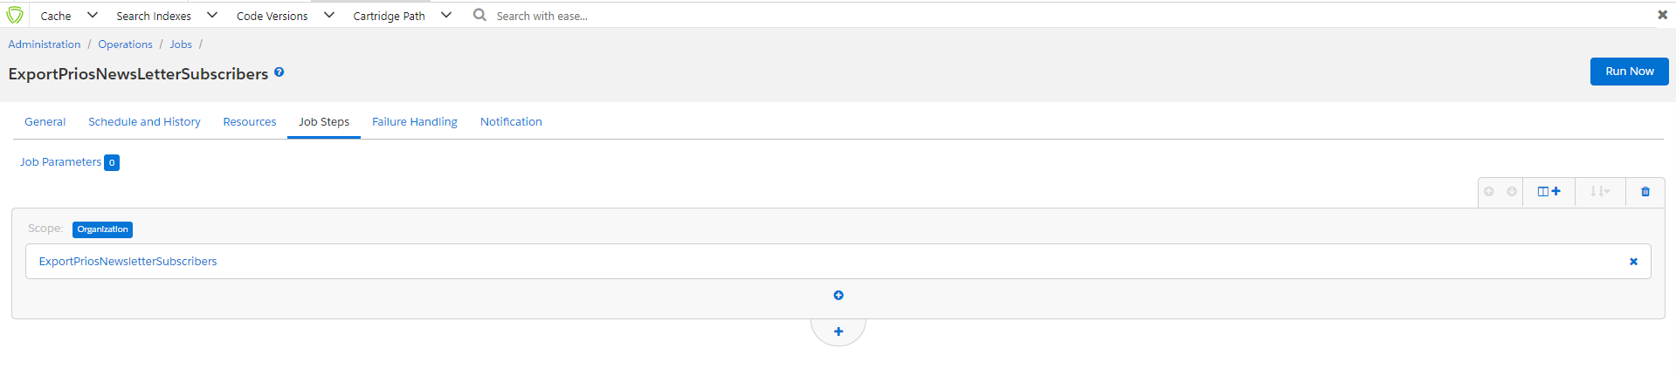

*For Job Failure Handling Configurations:*

*For Job Notification Configurations:*

*Configure From and To email address fields with the required email addresses*

## Storefront Functionality

*Since this is a Mobile App Integration, there are no changes in the storefront.*

# Known Issues

*There are no known issues with respect to the storefront. PRIOS Mobile app is compatible with iOS version 9 and above. It is not yet available for Android.*

# Release History

|  |  |  |
| --- | --- | --- |
| ***Version*** | ***Date*** | ***Changes*** |
| *17.1.0* | *Nov 27, 2017* | *Initial release* |
| *19.1.0* | *Feb 07, 2019* | *Second release – Re-certification* |
| *20.1.0* | *Apr 03, 2020* | *Third release – Re-certification* |
| *21.1.0* | *Jul 15, 2021* | *Fourth release – Re-certification* |
| *22.1.0* | *Jul 29, 2022* | *Fifth release – Re-certification* |
| *23.1.0* | *Feb 27, 2023* | *Sixth release – Re-certification* |

­